6.85: where s is the length of the rough patch.
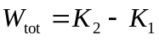
The work-energy relation gives 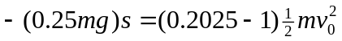
The mass divides out and solving gives 